CS 255 System Design Document Template

UML Diagrams
All of the diagrams I am going to show are the main parts of the DriverPass system based on the interview requirements. The design uses a blended object and process approach and focuses on the major functions needed to register customers, book driving lessons, manage accounts, track activity, and receive DMV updates.

UML Use Case Diagram
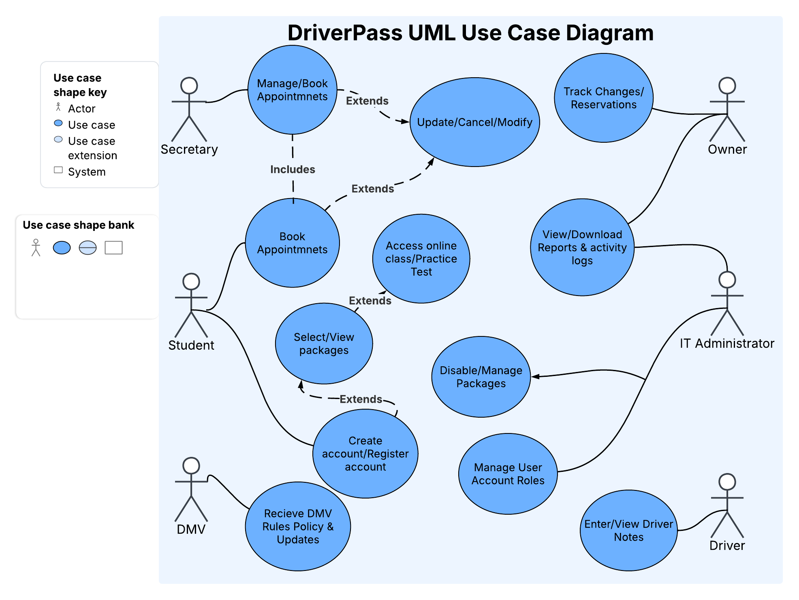

UML Activity Diagrams
The two use cases I selected are Register Customer Account and Book Driving Lesson. These were chosen because registration and scheduling are central processes described in the DriverPass interview.

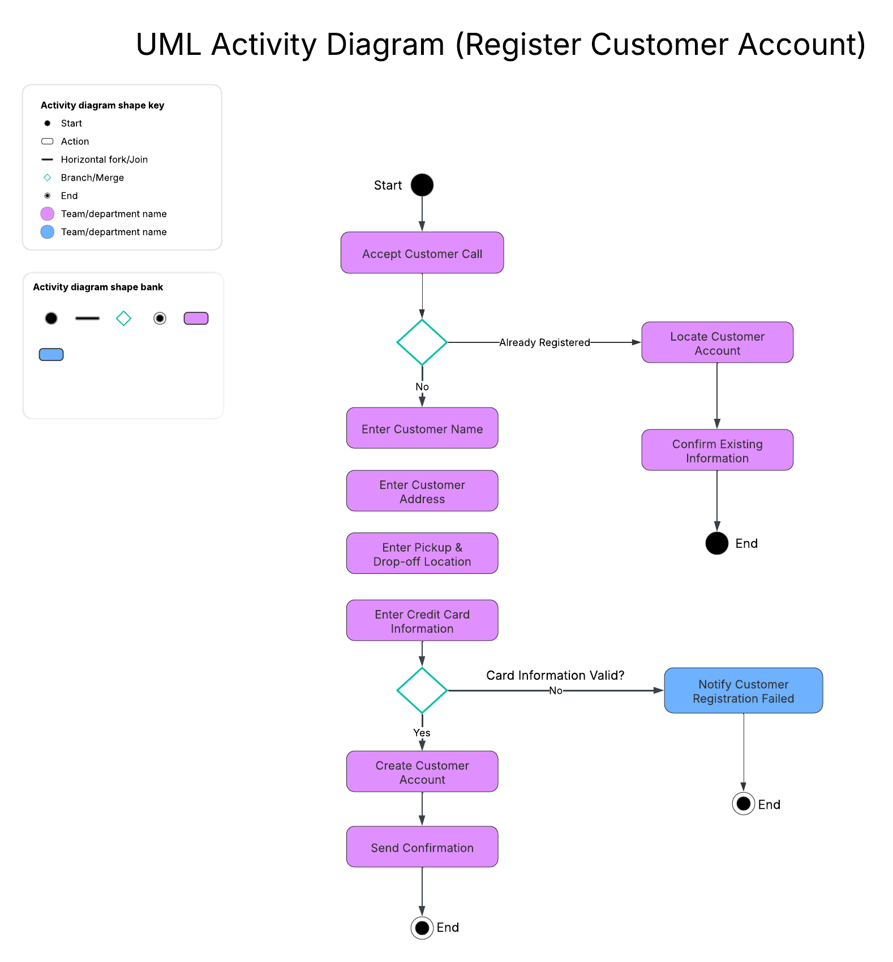
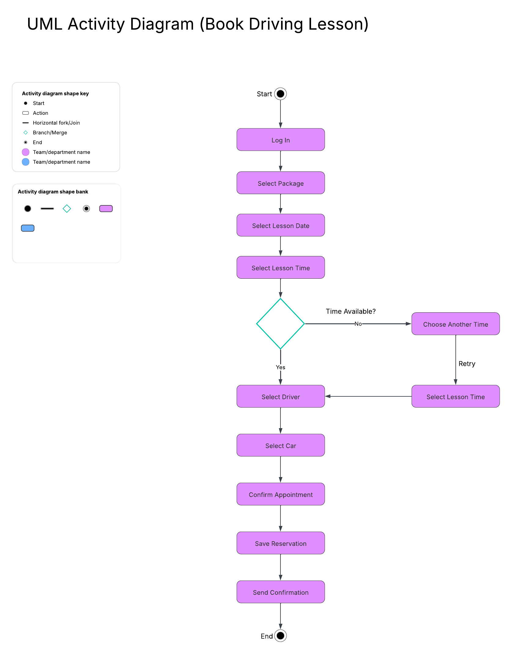

UML Sequence Diagram
My sequence diagram models the Register Customer Account use case. It shows the order of communication between the Secretary, Customer, and DriverPass system as customer information is collected, verified, stored, and confirmed.
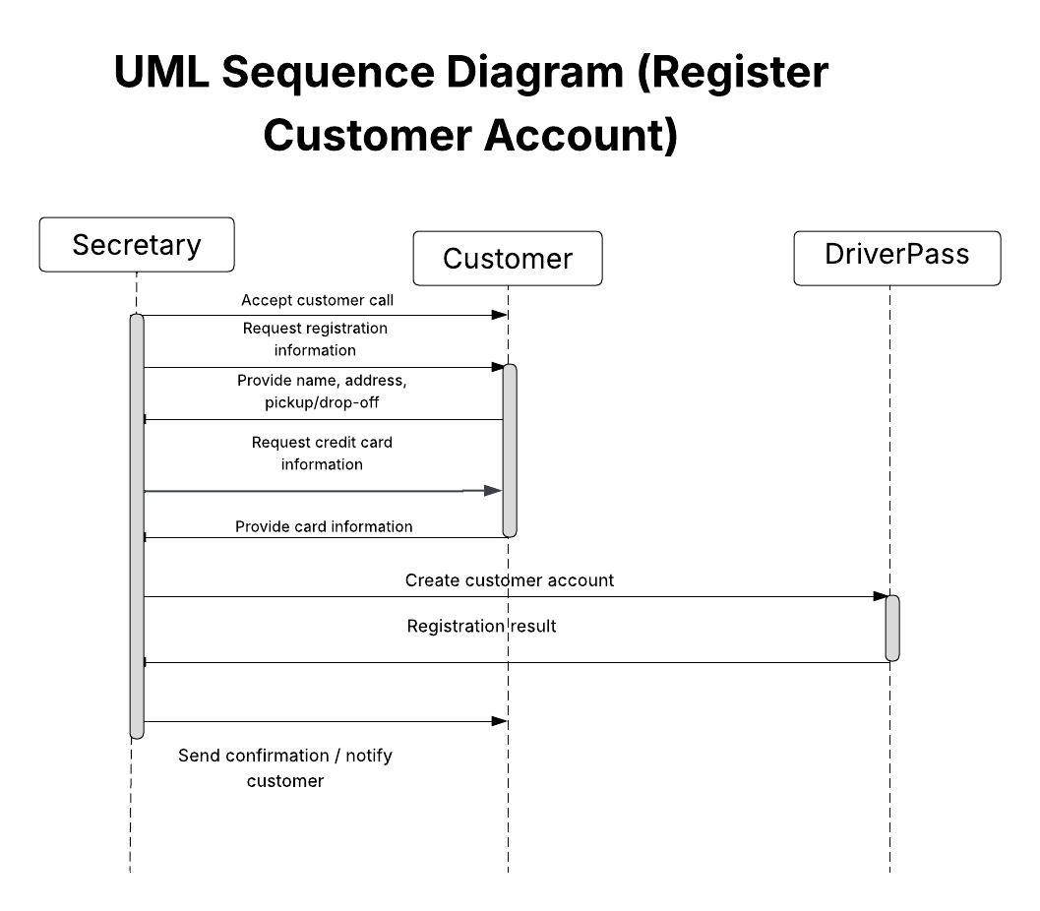

UML Class Diagram
My class diagram identifies the main objects and information needed for the system. It includes user and employee roles, customers, appointments, drivers, vehicles, packages, online course content, and practice tests.
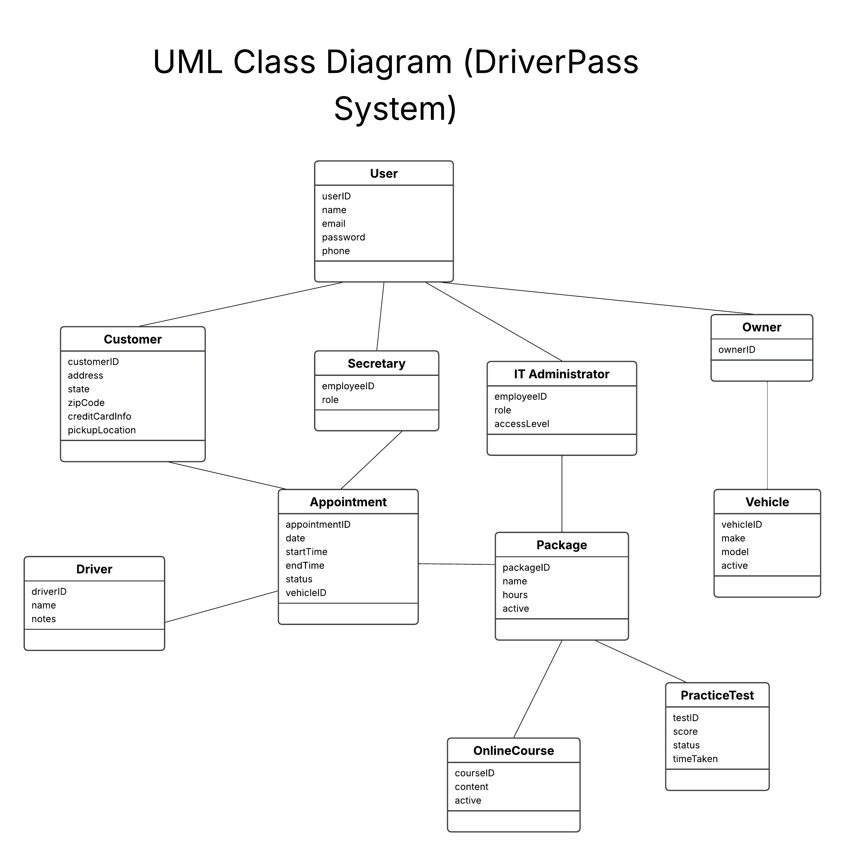

Technical Requirements
I think using a cloud based server would be a good option because it can help keep costs down and make it easier to expand later. Computers should be provided for the administrative staff, preferably using Windows since it is commonly used and easy to manage. The system should also have automatic backups to protect important information like customer and administrative data, along with security software to help protect the system from viruses. A reliable internet connection will also be important so employees can stay updated on schedules, reservations, and any new information from the DMV. The DriverPass website should also work on common devices and operating systems, including Windows, MacOS, iOS, and Android, so customers can easily access the system no matter what device they use.

